System Design Document

Introduction

Purpose

The Asian food world is a web based platform with information about Asian food, chefs, recipes and pack of images that people can view.
Its purpose is to enable people to view the web pages and search the recipes and chefs online. Also allow that interacts with people who are interest in Asian food as well as receiving updated newsletters after registering as a member.

Description

The solution is a web application that allows users to get information, view and search asian food online. It will also allow people to make interaction with each other, register as a member to view updated products and services.

Scope

The first release will focus on online searching of chefs and its related recipes.
The user story is:
- As a user I want to view website information and get new information about it quickly.
The supporting user story:
- As an administrator, I want to publish our products online so that more people can visit our website.
- As a user, I want to be able to view and search products online.
- As an administrator, I want to be able to manage user permissions as well as groups.

Target Users
List the users of the application for this release.
The users of the application of this release will be:
- Customer - purchase products online
- Salesperson - take orders, exchange products, services, support
- Administration user - enter data about products and pricing

Solution Design

Architecture overview
The solution will be built using a Content Management System (CMS) which provides the engine for the website, and allows a simple and fast way to develop a first working solution.
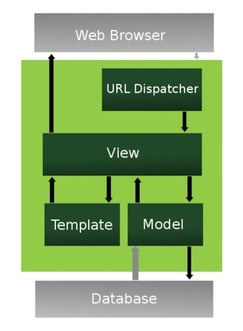
The diagram below gives an overview of one CMS architecture, for the Django framework, which is based on the Model-View –Controller pattern.
The CMS provides developers with templates for:
- The models (which are the entities to be stored in the database)
- The views (which represent the user interface or web pages that get displayed on the browser)
The CMS provides
- The controller through its framework (light green box) and the URL dispatcher
Developers will define the Views (based on templates) and the Models and the CMS will provide the rest.

Image Source: fishwarter (2009). The Django Web Application Framework. Retrieved from https://www.slideshare.net/fishwarter/the-django-web-application-framework-2-1221388

The sections below will document the Model and Views that are required for this application.

Model Design (Data Model)
This is the “model” part of the MVC pattern.
We refine the high level business domain model and create a detailed data model with all the entities that we will need to store in the database, with their attributes and relationships.
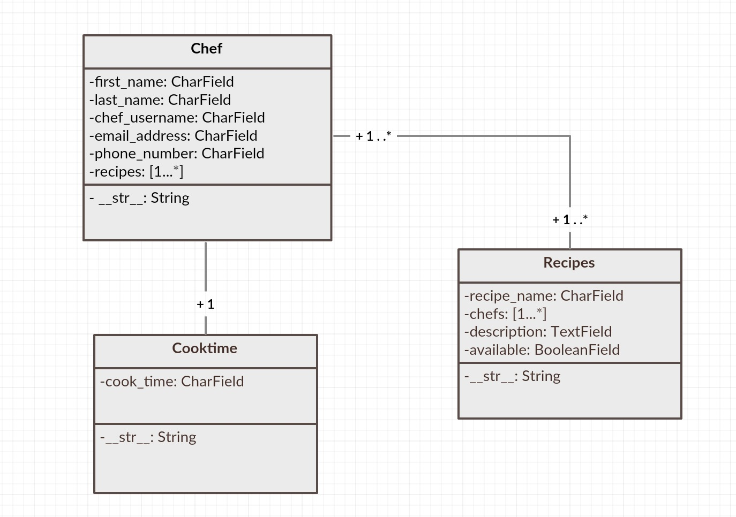

Functional Decomposition
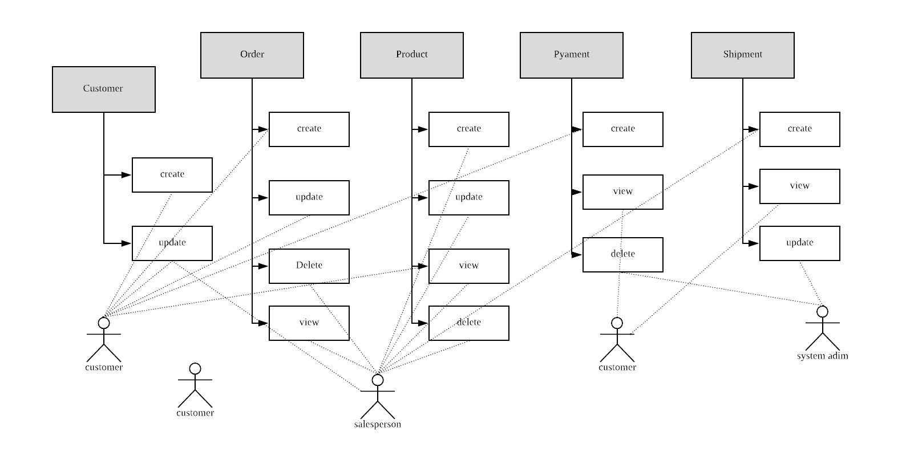

View Design (UI List)
This is the “view” part of the MVC pattern.
List the user interfaces needed to perform each user story.
Overall site map will need:
- Homepage
- About us page
- Contact us page
- Purchase page
- Gallery page
- Log on page

User Story 1
As a store customer, I want to view products and services online and purchase what I want quickly and easily.
- View: Products
- View: select products/delete/update
- View: put products into cart
- View: shipment selection
- View: payment process

User Story 2
As a salesperson, I want to be able to manage orders so as to meet customer needs.
- Views: create order
- Views: update order
- Views: delete order
- Customer view/update

Design Considerations
This section include technical aspects derived from the non-functional requirements.

User authentication

Authenticate all registered customers
It will be managed by the content management system and record all the customer information and secure it on the database.

authenticate all staff users
It will be provided by the content management system. It will be configured so as to provide staff with user logon, with the following user groups:
- Administrator (full access)
- Salesperson (create, update on orders)
- General staff (read only)
User IDs and passwords will be encrypted.

Security
Security requirements to be included:
- Prevent the system from most common security threats and attacks.
- Protect customer information.
- Use a secure payment process.
- Provide electronic order confirmation.

Usability
- Application must use intuitive design, with easy navigation and functions for users to view the product and make a order.

Portablilty
- The mobile phone interface is the first priority for customers.
- For staff users, the first priority is desktop and tablet.

Detailed Design
The detailed design of the user interfaces will documented individually, in separate documents.

